**Phase 2: Org Setup & Configuration**

**Salesforce Edition**

* **Edition Used**: Developer Edition.
* **Reason**: Provides free access to customization (Objects, Flows, Triggers, Dashboards). Ideal for building and testing a restaurant-focused CRM system.

**Company Profile Setup**

* **Company Name** :Gourmet Bistro Chain
* **Default Time Zone**: (GMT+5:30) IST (India).
* **Currency**: INR. Multi-currency enabled if expanding to global restaurant chains.

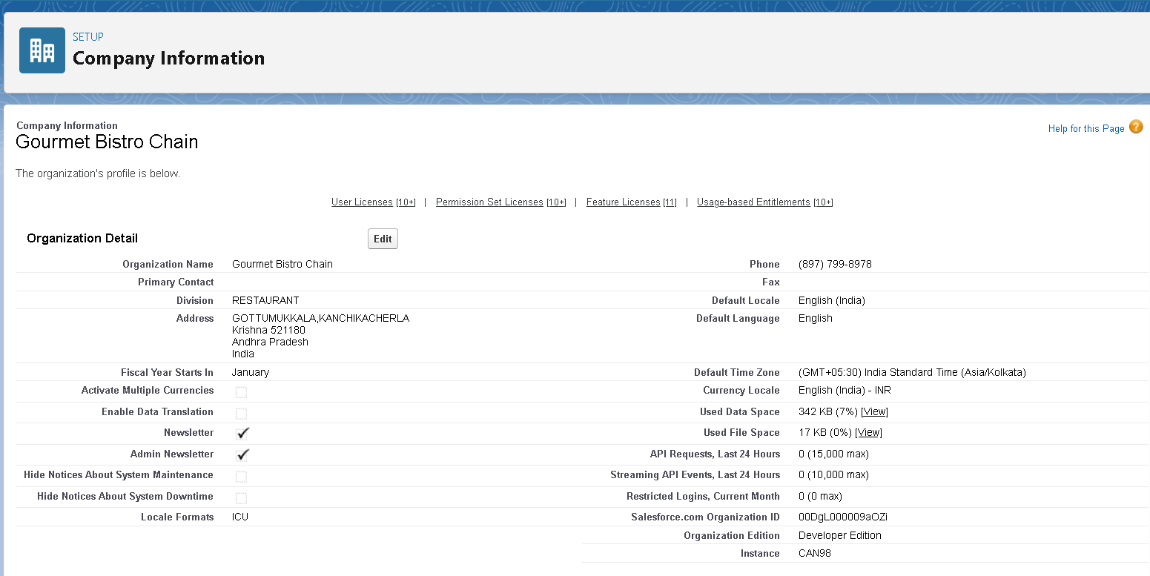

**Business Hours & Holidays**

* **Business Hours**: Mon–Sun, 10:00 AM – 10:00 PM IST.

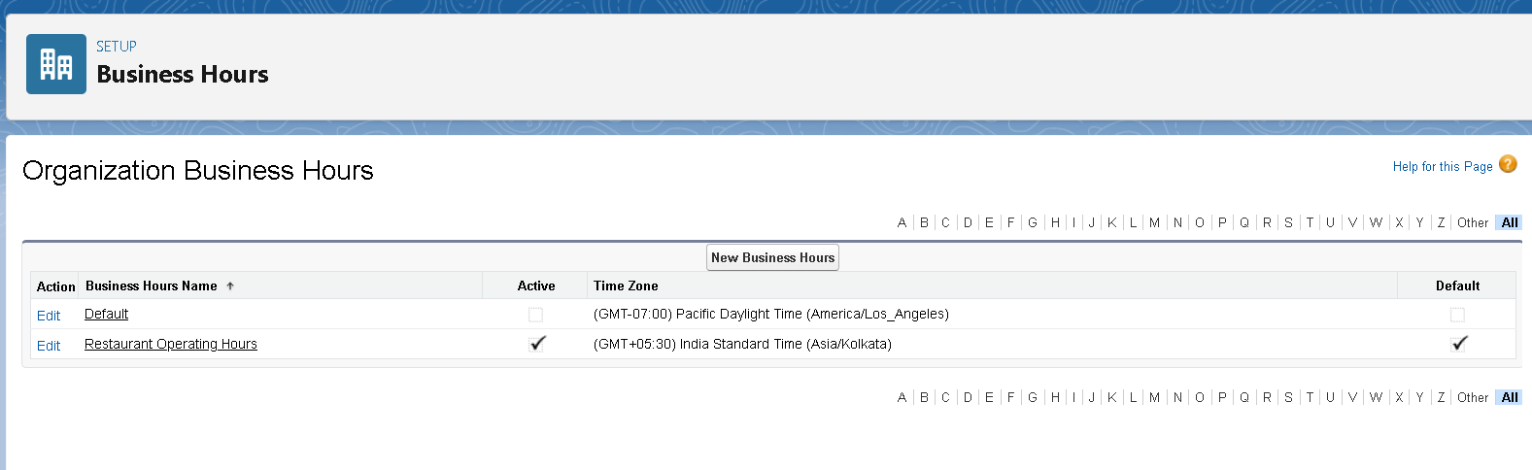

**Fiscal Year Settings**

* **Fiscal Year**: April–March (common for hospitality businesses in India).  
  **Reason**: Aligns reporting and forecasting with the industry’s accounting year.
* **Holidays**: Diwali, Christmas, Independence Day, Republic Day.  
  **Reason**: Ensures SLAs, reservations, and workflows align with restaurant working hours and skip holidays.

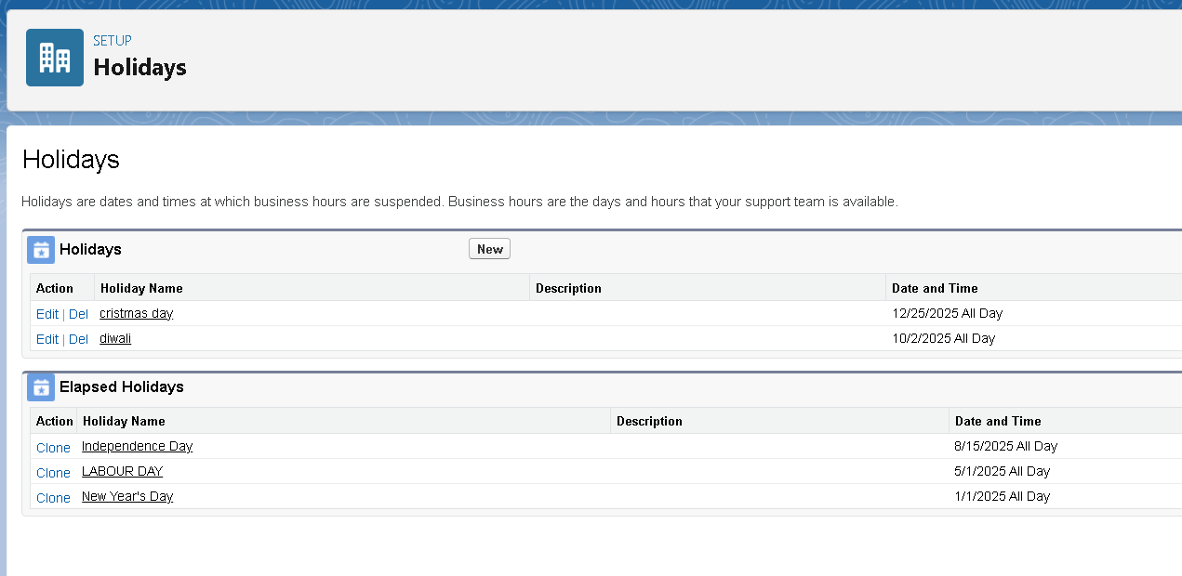

**User Setup & Licenses**

| **User** | **Role** | **License** |
| --- | --- | --- |
| Owner/Manager | CEO/Manager | Salesforce |
| Host/Hostess | FOH Staff | Salesforce |
| Waiter/Server | Service Staff | Salesforce |
| Kitchen Staff | Kitchen Staff | Salesforce |
| Marketing Staff | Marketing | Salesforce |

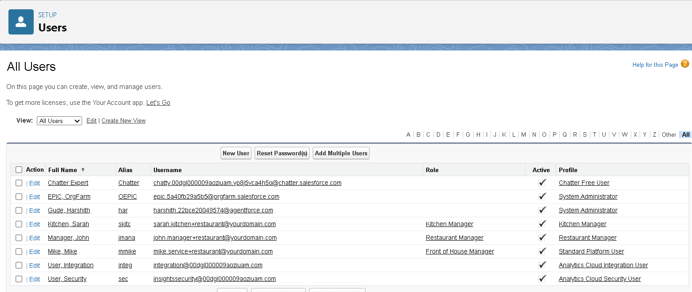

|  |  |  |  |
| --- | --- | --- | --- |
| Role | Reports To | Responsibilities | Data Visibility |
| CEO | Top Level | Strategic decisions, overall business growth | Sees all records |
| Restaurant Manager | CEO | Oversee daily operations, customer experience | Sees all restaurant-related records |
| Customer Service Rep | Restaurant Manager | Handle customer queries, feedback, complaints | Sees assigned customer cases |
| Front of House Manager | Restaurant Manager | Manage dining area, supervise FOH staff | Sees reservations + FOH staff activities |
| Cashier | Front of House Manager | Billing, payments, receipts | Sees assigned transactions |
| Host/Hostess | Front of House Manager | Manage reservations, seat customers | Sees assigned reservations |
| Waitstaff | Front of House Manager | Take orders, serve food, customer interaction | Sees assigned reservations + orders |
| Kitchen Manager | Restaurant Manager | Oversee kitchen, ensure food quality/timeliness | Sees all kitchen orders |
| Inventory Coordinator | Kitchen Manager | Track supplies, stock levels, ordering | Sees inventory + purchase data |
| Kitchen Staff | Kitchen Manager | Prepare food, handle dietary requests | Sees assigned orders |
| Supplier Manager | Restaurant Manager | Manage supplier relations, procurement | Sees supplier and purchase records |

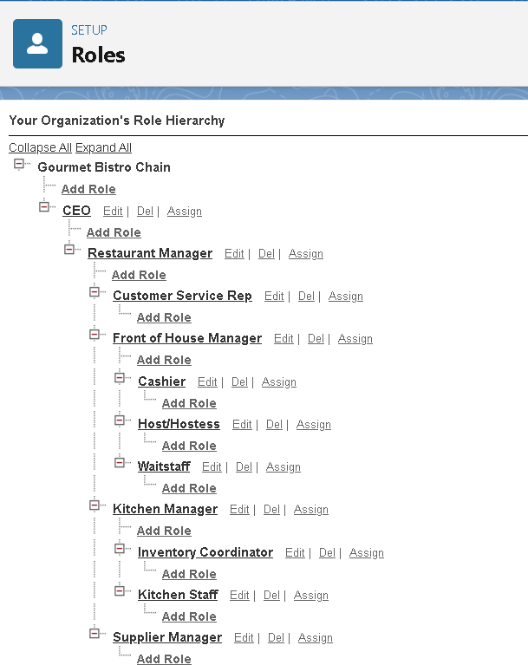

**Profiles**

* **Manager Profile**: Full access to all objects (Customers, Reservations, Orders, Feedback, Campaigns).
* **FOH Staff Profile**: Read/Write on Reservations, Read on Customers, no access to Campaigns.
* **Service Staff Profile**: Read on Reservations, Read/Write on Orders and Feedback, no access to Campaigns.
* **Kitchen Staff Profile**: Read on Reservations and Orders (with dietary restrictions fields).
* **Marketing Profile**: Full access to Campaigns, Read access to Customers, limited access to Reservations.

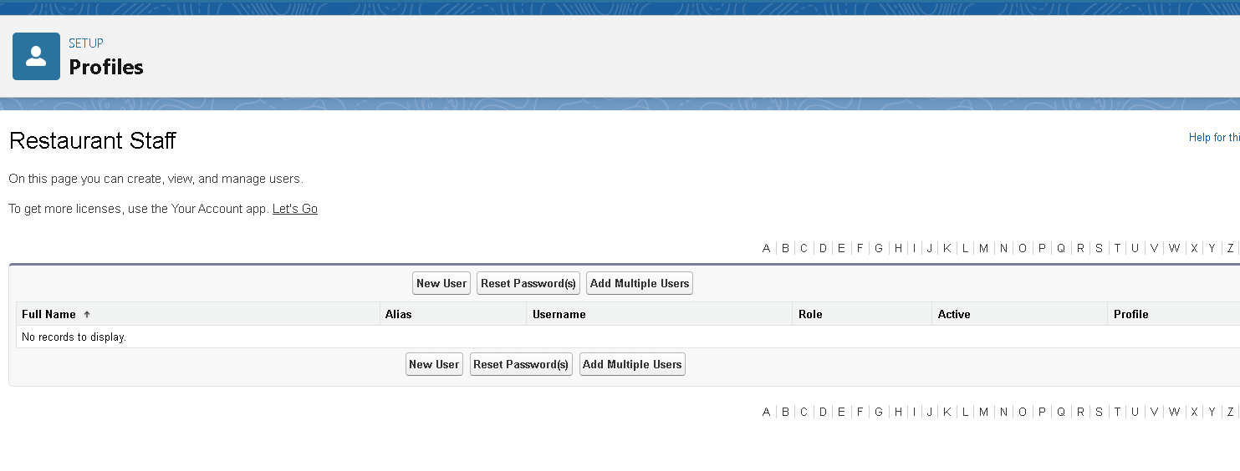

**Permission Sets**

* **Reports Access**: For Manager & Marketing to create dashboards.
* **Reservation Management**: For FOH to manage bookings.
* **Order Management**: For Service Staff to update order status.
* **Dietary Preferences Access**: For Kitchen Staff to view allergies/dietary notes.

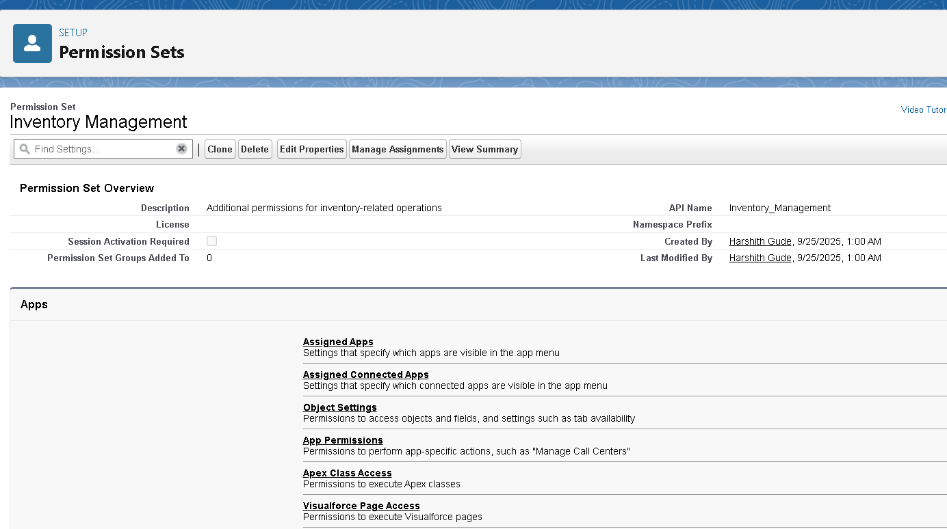

**Organization-Wide Defaults (OWD)**

* **Customer Profiles**: Private.
* **Reservations**: Private (shared via role hierarchy).
* **Orders**: Controlled by Reservation (Service/Kitchen can see their linked records).
* **Feedback**: Private (visible to Manager and Marketing).
* **Campaigns**: Public Read/Write (Marketing team).

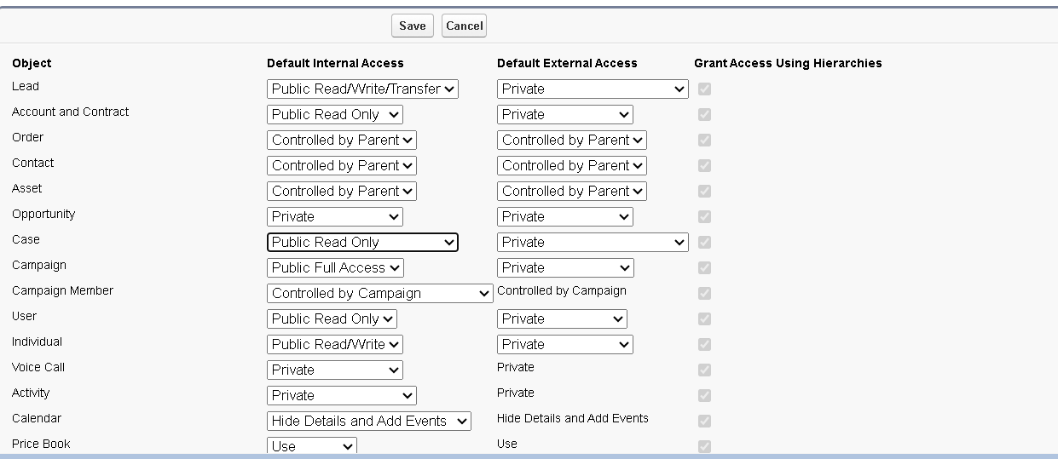

**Sharing Rules**

* Reservations with Status = "Confirmed" → Shared with assigned FOH and Service Staff.
* Orders with Dietary Restrictions = "Yes" → Shared with Kitchen Staff role.
* Feedback records → Shared with Marketing role (Read Only).

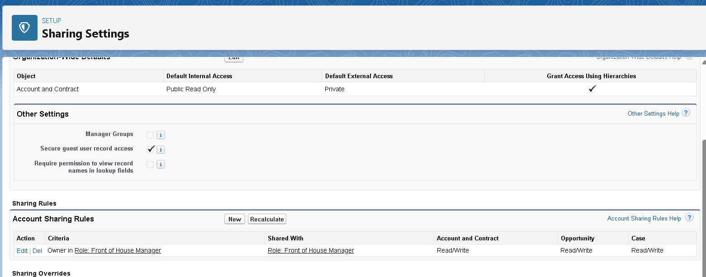

**Login & Security Policies**

* Password Policy: Minimum 10 characters, lockout after 3 failed attempts.
* Session Timeout: 30 minutes.
* 2FA Enabled for Manager role.
* IP Restrictions: FOH and Service Staff logins restricted to restaurant network.

**Audit Trail & Field History**

* Field History Tracking on **Reservations** (Status, Assigned Table).
* Field History Tracking on **Orders** (Special Notes, Amount).
* Setup Audit Trail enabled for monitoring admin changes.

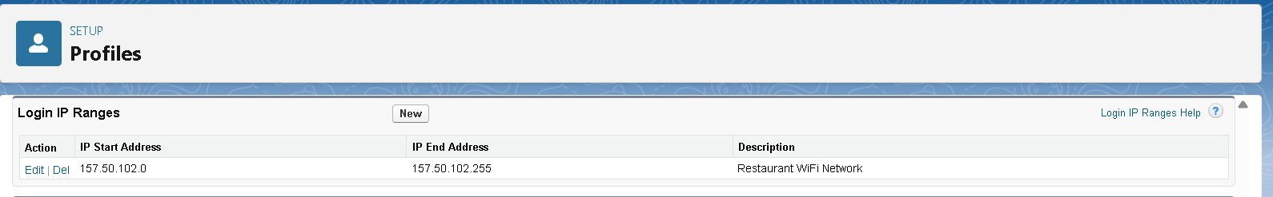

**Developer Org Setup & Deployment**

* **Org Type**: Developer Edition (no Sandboxes).
* **Testing**: Use a second Developer Org for QA.
* **Deployment Options**:
  + Change Sets for small changes.
  + Salesforce DX + GitHub for version control, CI/CD, and scratch orgs.

